STRR DEMONSTRATION REPORT – 1
Seed to Harvest
Details Of Farmer
Name of Farmers | RAJU SINGH
Mobile No. | 9801072651
Village Name | PURSOTIPUR
Block & Tehsil | ITADHI
District & State | BUXAR

Field And Crop Detail
Total Acreage(acre) | 10 ACRE
Crops Grown | 10 ACRE
Field Location (Easy approach/road side) | ROAD SIDE
Selected - Crop & Variety | PADDY MTU-7029
Trial Plot Area (KATHA) | 28 KATHA (INCULDING T1+ T2)
Seed Rate (kg/acre) | 8 KG/ACRE
Sowing Date | 14.07.2025

Demo Product Name And Dose& Field day detail
Name of Product | SALTON
Application Dose (ml/acre) | 3.5 KG
Date/Time of Application | 14.07.2025
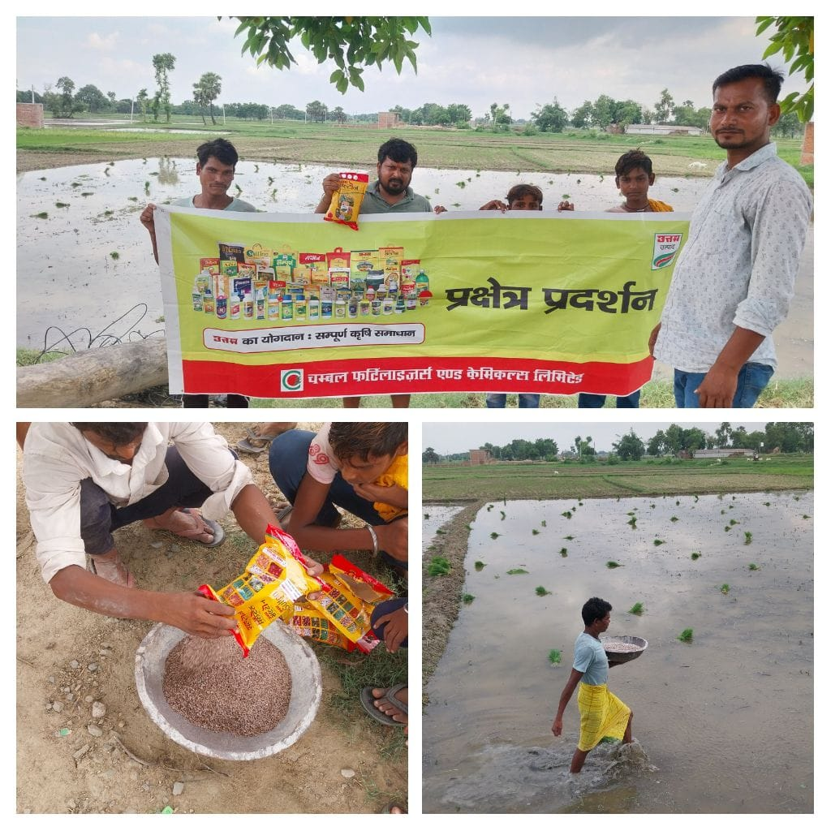
STRR DEMONSTRATION REPORT – 2
Seed to Harvest
Details Of Farmer
Name of Farmers | BINOD KUMAR SHARMA
Mobile No. | 9955638861
Village Name | KHOCHARIHA
Block & Tehsil | RAJPUR
District & State | BUXAR

Field And Crop Detail
Total Acreage(acre) | 30 ACRE
Crops Grown | 30 ACRE
Field Location (Easy approach/road side) | ROAD SIDE
Selected - Crop & Variety | PADDY MTU-7029
Trial Plot Area (KATHA) | 32 KATHA (INCULDING T1+ T2)
Seed Rate (kg/acre) | 8 KG/ACRE
Sowing Date | 14.07.2025

Demo Product Name And Dose& Field day detail
Name of Product | SALTON
Application Dose (ml/acre) | 4 KG
Date/Time of Application | 14.07.2025

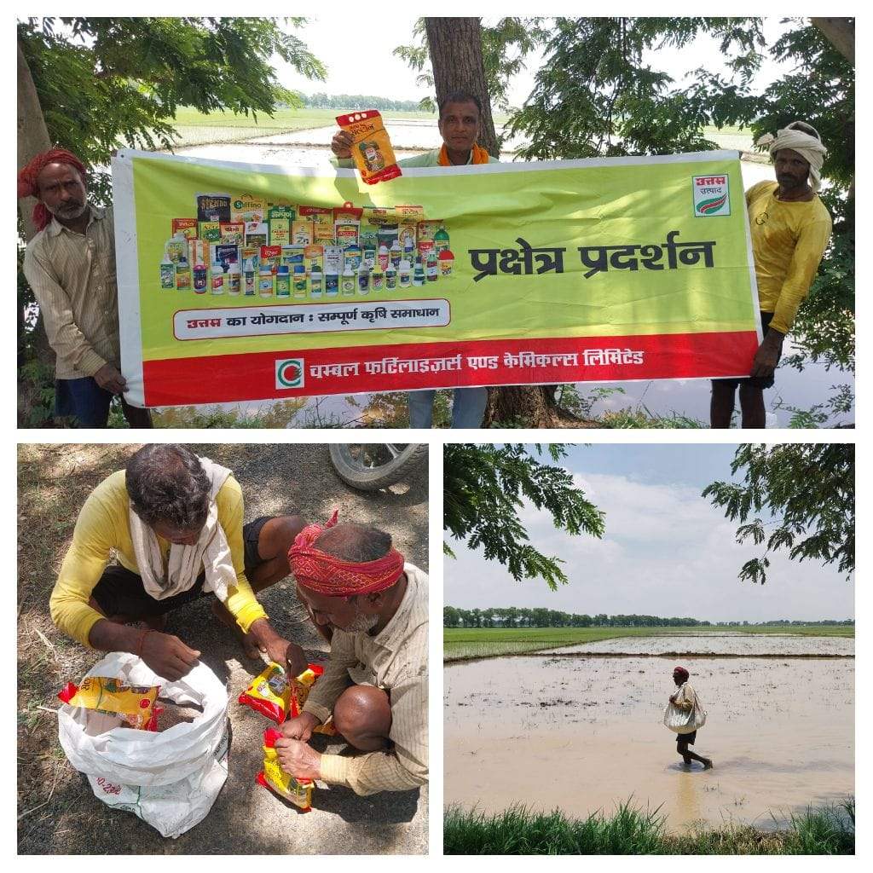

STRR DEMONSTRATION REPORT – 3
Seed to Harvest
Details Of Farmer
Name of Farmers | VIKASH KUMAR
Mobile No. | 7061276288
Village Name | UDAIPURA INDURE
Block & Tehsil | ITADHI
District & State | BUXAR

Field And Crop Detail
Total Acreage(acre) | 10 ACRE
Crops Grown | 10 ACRE
Field Location (Easy approach/road side) | ROAD SIDE
Selected - Crop & Variety | PADDY MTU-7029
Trial Plot Area (KATHA) | 30 KATHA (INCULDING T1+ T2)
Seed Rate (kg/acre) | 8 KG/ACRE
Sowing Date | 15.07.2025

Demo Product Name And Dose& Field day detail
Name of Product | SALTON
Application Dose (ml/acre) | 3.75 KG
Date/Time of Application | 15.07.2025

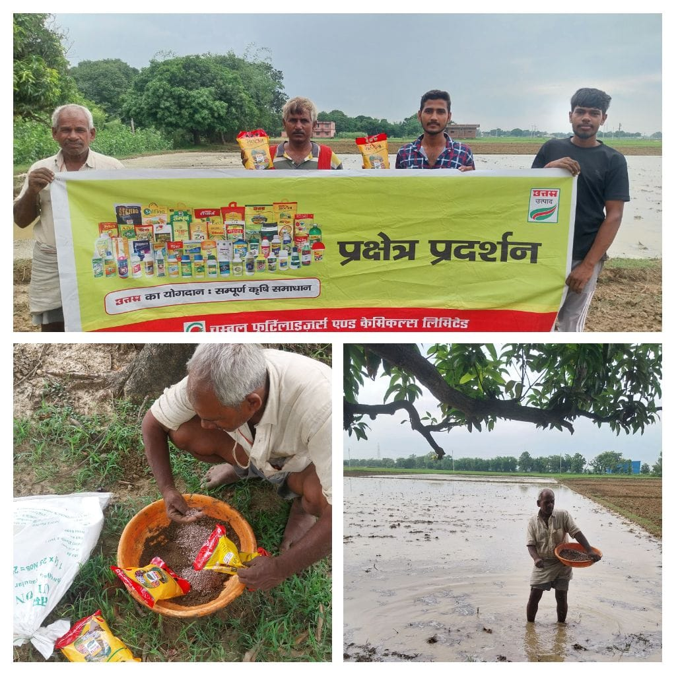

STRR DEMONSTRATION REPORT – 4
Seed to Harvest
Details Of Farmer
Name of Farmers | MANOJ PANDEY
Mobile No. | 9122156029
Village Name | KATARIYA
Block & Tehsil | RAJPUR
District & State | BUXAR

Field And Crop Detail
Total Acreage(acre) | 15 ACRE
Crops Grown | 15 ACRE
Field Location (Easy approach/road side) | ROAD SIDE
Selected - Crop & Variety | PADDY MTU-7029
Trial Plot Area (KATHA) | 32 KATHA (INCULDING T1+ T2)
Seed Rate (kg/acre) | 8 KG/ACRE
Sowing Date | 04.07.2025

Demo Product Name And Dose& Field day detail
Name of Product | SALTON
Application Dose (ml/acre) | 4KG
Date/Time of Application | 04.07.2025

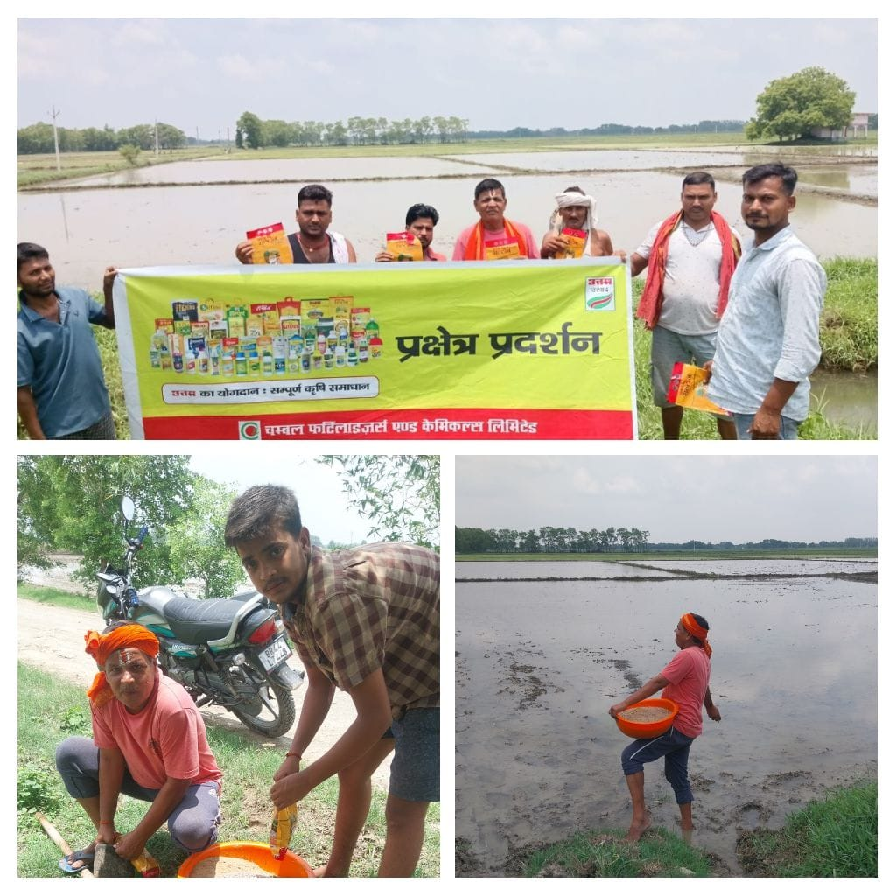

STRR DEMONSTRATION REPORT – 5
Seed to Harvest
Details Of Farmer
Name of Farmers | GOLU RAI
Mobile No. | 9006895411
Village Name | KANEHARI
Block & Tehsil | RAJPUR
District & State | BUXAR

Field And Crop Detail
Total Acreage(acre) | 15 ACRE
Crops Grown | 15 ACRE
Field Location (Easy approach/road side) | EASY APPROCH
Selected - Crop & Variety | PADDY MTU-7029
Trial Plot Area (KATHA) | 32 KATHA (INCULDING T1+ T2)
Seed Rate (kg/acre) | 08 KG/ACRE
Sowing Date | 05.07.2025

Demo Product Name And Dose& Field day detail
Name of Product | SALTON
Application Dose (ml/acre) | 4 KG
Date/Time of Application | 05.07.2025

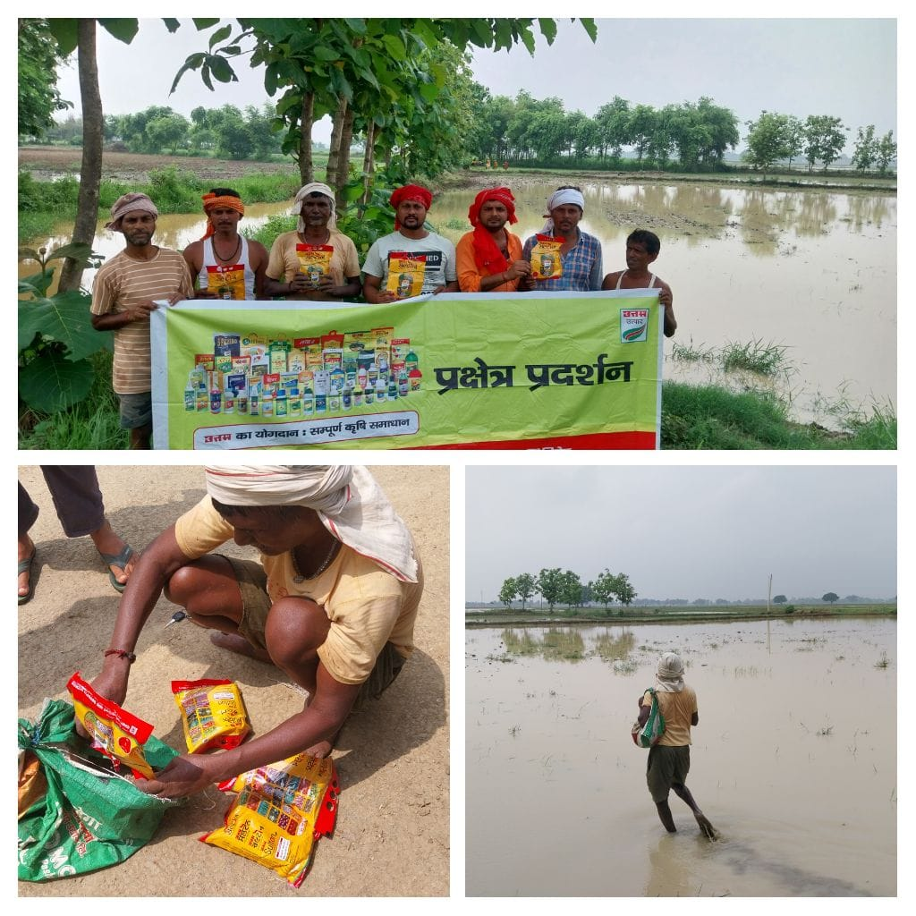
STRR DEMONSTRATION REPORT – 6
Seed to Harvest
Details Of Farmer
Name of Farmers | SANJAY KUMAR SINGH
Mobile No. | 9504415958
Village Name | UNWAS
Block & Tehsil | ITADHI
District & State | BUXAR

Field And Crop Detail
Total Acreage(acre) | 25 ACRE
Crops Grown | 25 ACRE
Field Location (Easy approach/road side) | ROAD SIDE
Selected - Crop & Variety | PADDY MTU-7029
Trial Plot Area (KATHA) | 32 KATHA (INCULDING T1+ T2)
Seed Rate (kg/acre) | 8 KG/ACRE
Sowing Date | 05.07.2025

Demo Product Name And Dose& Field day detail
Name of Product | SALTON
Application Dose (ml/acre) | 4 KG
Date/Time of Application | 05.07.2025

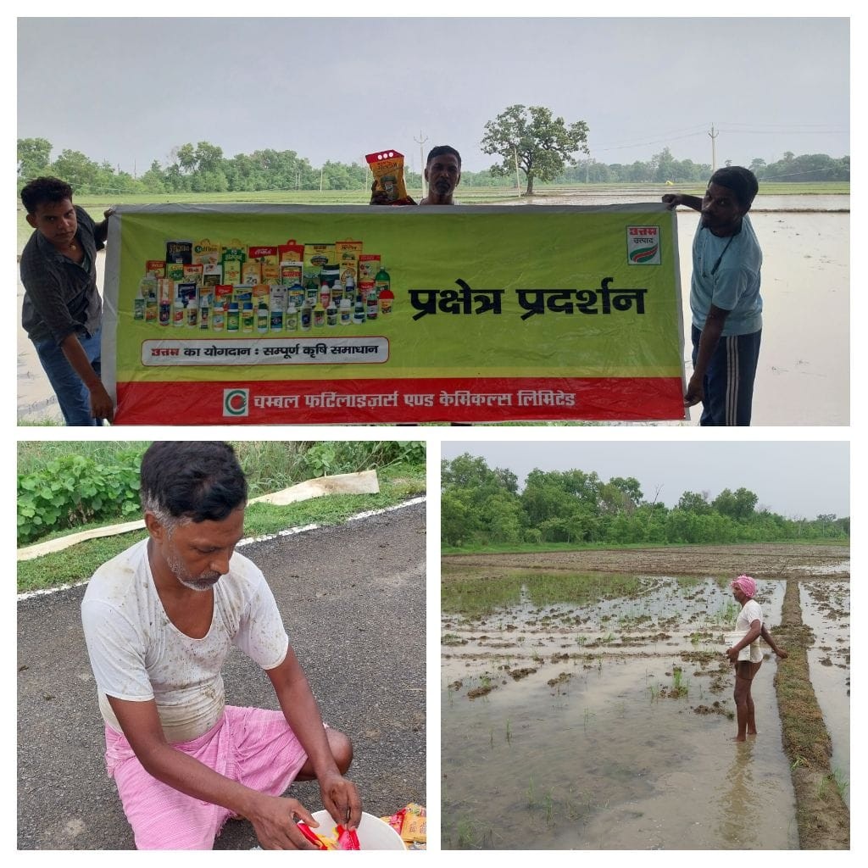

STRR DEMONSTRATION REPORT – 7
Seed to Harvest
Details Of Farmer
Name of Farmers | RAM SINGH
Mobile No. | 7323926098
Village Name | HETHUA
Block & Tehsil | RAJPUR
District & State | BUXAR

Field And Crop Detail
Total Acreage(acre) | 20 ACRE
Crops Grown | 20 ACRE
Field Location (Easy approach/road side) | EASY APPROACH
Selected - Crop & Variety | PADDY MTU-7029
Trial Plot Area (KATHA) | 32 KATHA (INCULDING T1+ T2)
Seed Rate (kg/acre) | 08 KG/ACRE
Sowing Date | 17.07.2025

Demo Product Name And Dose& Field day detail
Name of Product | SALTON
Application Dose (ml/acre) | 4 KG
Date/Time of Application | 17.07.2025

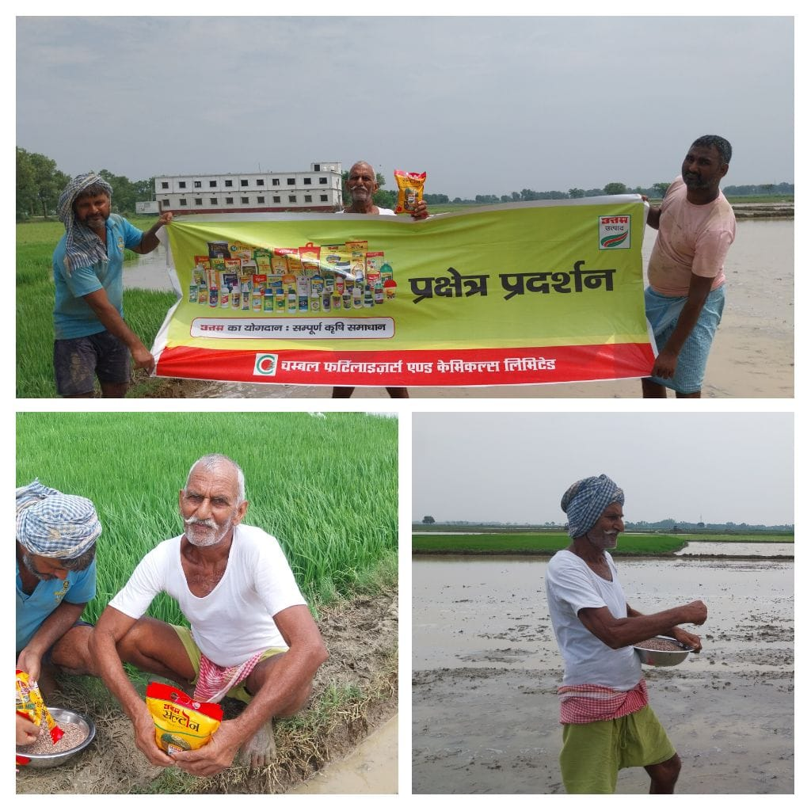

STRR DEMONSTRATION REPORT – 8
Seed to Harvest
Details Of Farmer
Name of Farmers | DEVRAJ SINGH
Mobile No. | 8521990296
Village Name | UATTARI KALA
Block & Tehsil | RAJPUR
District & State | BUXAR

Field And Crop Detail
Total Acreage(acre) | 08 ACRE
Crops Grown | 08 ACRE
Field Location (Easy approach/road side) | ROAD SIDE
Selected - Crop & Variety | PADDY MTU-7029
Trial Plot Area (KATHA) | 32 KATHA (INCULDING T1+ T2)
Seed Rate (kg/acre) | 08 KG/ACRE
Sowing Date | 17.07.2025

Demo Product Name And Dose& Field day detail
Name of Product | SALTON
Application Dose (ml/acre) | 4KG
Date/Time of Application | 17.07.2025

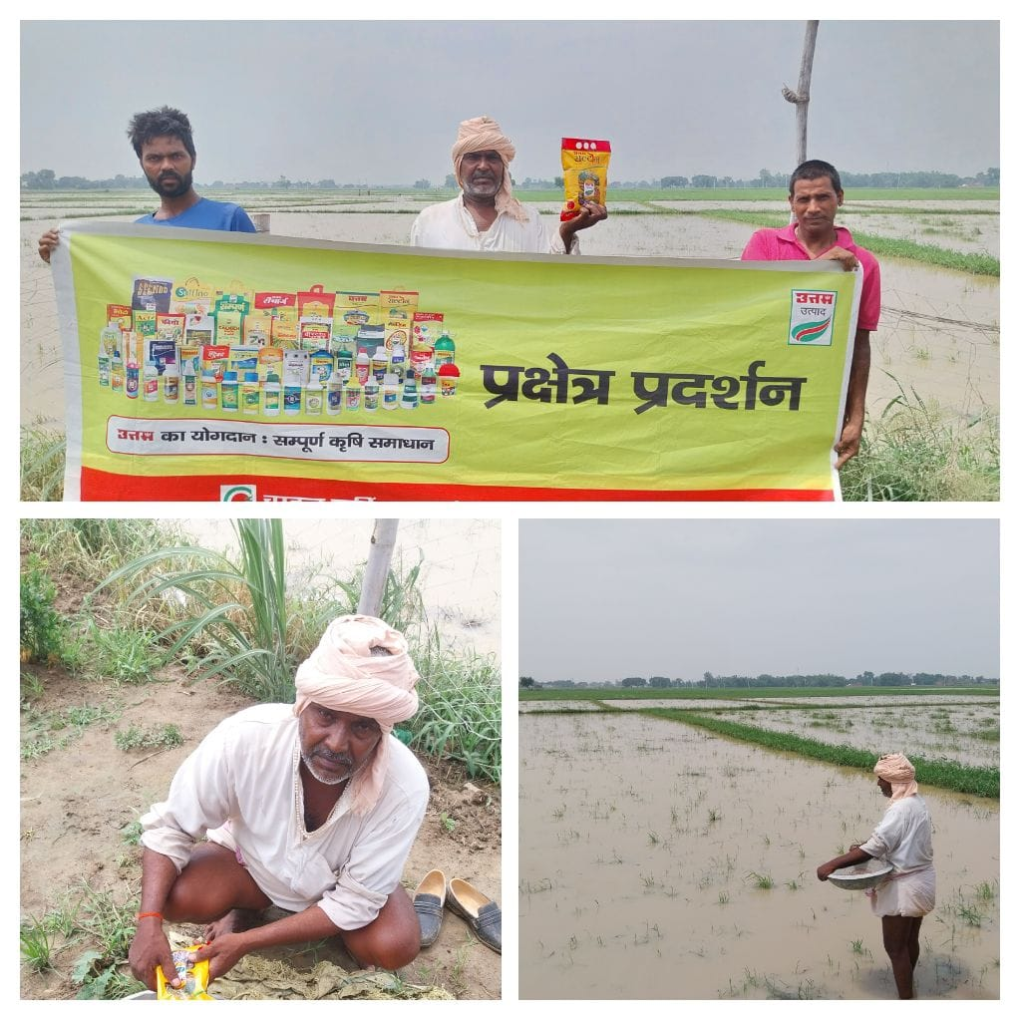

STRR DEMONSTRATION REPORT – 9
Seed to Harvest
Details Of Farmer
Name of Farmers | ANIRUDH SINGH
Mobile No. | 8002661545
Village Name | HANKARPUR
Block & Tehsil | RAJPUR
District & State | BUXAR

Field And Crop Detail
Total Acreage(acre) | 05 ACRE
Crops Grown | 05 ACRE
Field Location (Easy approach/road side) | EASY APPROCH
Selected - Crop & Variety | PADDY MTU-7029
Trial Plot Area (KATHA) | 22 KATHA (INCULDING T1+ T2)
Seed Rate (kg/acre) | 8 KG/ACRE
Sowing Date | 17.07.2025

Demo Product Name And Dose& Field day detail
Name of Product | SALTON
Application Dose (ml/acre) | 2.75 KG
Date/Time of Application | 17.07.2025

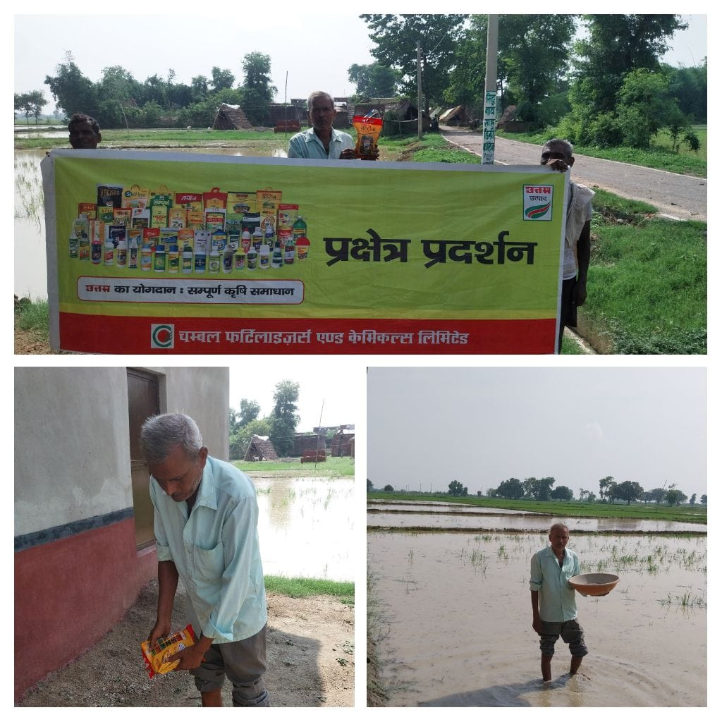
STRR DEMONSTRATION REPORT – 10
Seed to Harvest
Details Of Farmer
Name of Farmers | MD SAMIR ULLA ANSARI
Mobile No. | 8294609053
Village Name | KHIRI
Block & Tehsil | RAJPUR
District & State | BUXAR

Field And Crop Detail
Total Acreage(acre) | 8 ACRE
Crops Grown | 8 ACRE
Field Location (Easy approach/road side) | EASY APPROCH
Selected - Crop & Variety | PADDY MTU-7029
Trial Plot Area (KATHA) | 20 KATHA (INCULDING T1+ T2)
Seed Rate (kg/acre) | 8 KG/ACRE
Sowing Date | 17.07.2025

Demo Product Name And Dose& Field day detail
Name of Product | SALTON
Application Dose (ml/acre) | 2.5 KG
Date/Time of Application | 17.07.2025
